Hospital management system

Abstract
This project presents a simple Hospital Patient Management System developed in the C programming language. The system is designed to help store and manage basic patient information, including name, age, disease, and admission status. Using a menu-driven approach, the program allows users to perform essential operations such as adding new patients, displaying all patient records, searching for patients by disease, listing admitted patients, counting the number of admitted individuals, and calculating the average age of all patients. The program uses structures to efficiently organize patient data and implements fundamental concepts such as loops, arrays, string handling, and conditional statements. This system provides a clear demonstration of how C can be used to build simple, efficient data-handling applications

Problem Definition.
Managing patient information in hospitals can be challenging when done manually. Recording details such as patient names, ages, diseases, and admission status on paper often leads to errors, difficulty in searching records, and slow access to information. To solve these issues, there is a need for a simple computerized system that can store, manage, and retrieve patient data efficiently.
This project aims to develop a basic Hospital Management System using the C programming language. The system should allow users to add patient details, display the complete list of patients, search for patients by disease, view admitted patients, count the total number of admitted individuals, and calculate the average age of all patients. By providing these operations in a menu-driven format, the system helps users manage patient records quickly, accurately, and conveniently.

Implementation Details
The Hospital Patient Management System is implemented in the C programming language using fundamental programming concepts such as structures, arrays, loops, and conditional statements. The system is entirely menu-driven, allowing the user to interact with different functionalities step-by-step.

1. Data Structure Used
A struct Patient is defined to store individual patient details. It contains:
- name – to store the patient’s full name
- age – to record the patient’s age
- disease – to store the diagnosed disease
- admitted – an integer flag (1 = admitted, 0 = not admitted)
An array of 100 Patient structures is used to maintain multiple records.

2. Input Handling
User inputs are collected using scanf().
- For strings with spaces, the format scanf(" %[^\n]", ...) is used to read full names and diseases.
- Numerical values like age and admitted status are taken using standard integer input.

3. Menu-Driven System
A continuous while(1) loop is used to display the menu and take user choices. Based on the selected option, the program performs specific operations:
- Add Patient – Stores all patient details and increments count.
- Display All Patients – Prints the full list of patient records.
- Search by Disease – Compares the input disease using strcmp() and displays matched patients.
- Display Admitted Patients – Shows only patients with admitted == 1.
- Count Admitted Patients – Iterates through the array to count admitted ones.
- Average Age – Calculates and displays the average age from all patient records.
- Exit – Ends the program.

4. Searching Mechanism
The program uses linear search to match disease names. strcmp() from the <string.h> library is used for string comparison.

5. Calculations
- Counting admitted patients is done by iterating through the array and checking the admitted flag.
- Average age is computed by summing all ages and dividing by the number of patients.

6. Loop and Condition Control
Control structures such as if-else, for loops, and switch-like menu logic ensure correct program flow and data processing.

7. Output Formatting
Clear labels and formatting using printf() make the menu and output easy to read.
All data is displayed in a structured line format for user convenience.

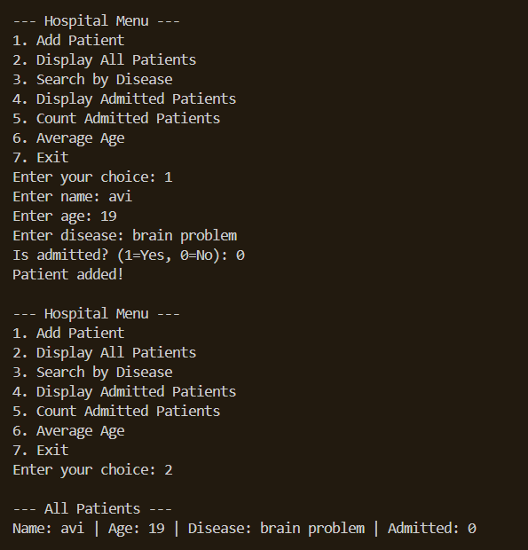
Testing & Results

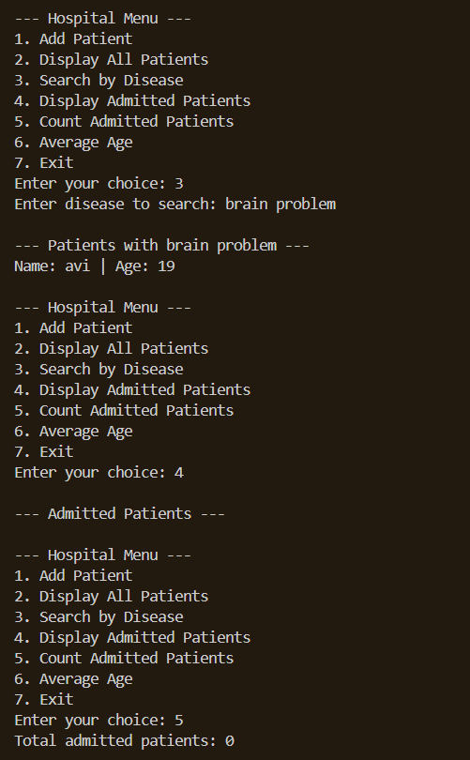

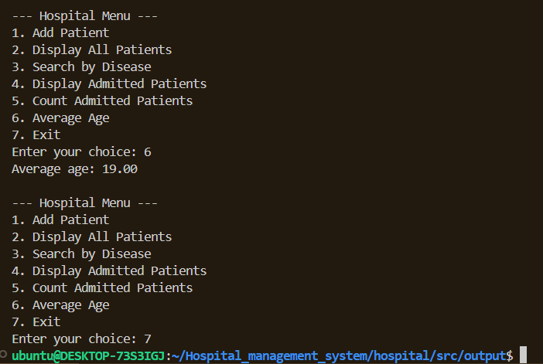

Conclusion & Future Work

Conclusion
The Hospital Patient Management System developed in C successfully demonstrates how basic data operations such as storing, displaying, searching, and analyzing information can be implemented using simple programming concepts. By using structures, arrays, loops, and conditional statements, the program effectively manages patient records and provides a user-friendly, menu-driven interface. Although simple, the system helps reduce manual errors, improves the speed of access to patient information, and serves as a strong foundation for understanding data handling in C programming.

Future Work
Although the current system is functional, several enhancements can be added to improve its usability and real-world application:
- File Handling
Add the ability to save patient records to a file and load them later, so data is not lost when the program exits.
- Record Deletion & Editing
Allow users to edit patient details or delete a record when required.
- Sorting
Implement sorting options such as sorting by age, name, or disease for better organization.
- Error Handling
Improve input validation (e.g., restricting negative ages or invalid admission values).
- Graphical User Interface (GUI)
Create a simple GUI using libraries like GTK or move to advanced languages to make the system visually appealing and easier to use.
- Database Integration
Integrate with MySQL or SQLite for scalable storage when dealing with large patient datasets.
- Modularization
Break the program into separate functions and files to improve readability and maintainability.
References

1) https://www.geeksforgeeks.org/
For problem I faced during making this project and help me a lot for understand the concepts clearly

2) https://www.wikipedia.org/
For the reference and information about the hospital and how it work

3) https://chatgpt.com/
For assistance about the problem I do not able to understand

